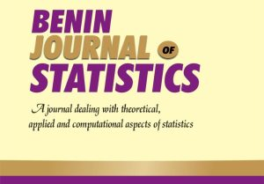
REVIEWERS FORM
BENIN JOURNAL OF STATISTICS: A DEPARTMENT JOURNAL
UNIVERSITY OF BENIN, BENIN CITY

TITLE:
MANUSCRIPT NUMBER:
TITLE: Does the title reflect the objective of the study? If No, suggest a better title.
ABSTRACT: Does the abstract capture the problem, method, results and findings? How suitable is the abstract in content and scope?
INTRODUCTION: How well is the study introduced? Does it capture the study gap/problem/objectives adequately? How current are the articles reviewed, and their relevance to the study?
METHOD AND MATERIALS: Is the method novel or adapted? Is the method appropriate for the study? If No, suggest a method appropriate for the study, or give a direction to enhance the novelty of the method.
RESULTS AND DISCUSSION: Are the results relevant, and well presented? How well are the results reflect the objectives of the study? Are the results appropriately and adequately discussed? To what extent do the findings different or similar to previous study? Are the findings from the result? Are the data collection method well described? Is the method well applied using the data? Are the Tables and Figures well presented?
CONCLUSION: Is the conclusion robust? Does it reflect the content of the study?
ORIGINALITY AND ARTICLE STRUCTURE: How do you assess the article in terms of originality? Is the paper well written?
REFERENCES: How is the currency of the references? Are all the referenced works cited in the body of the article? Are all citations appropriately referenced?
ANY OTHER COMMENTS
Accept with Major Revision
Accept with Minor Revision
Reject
DECISION: REVIEWER’S
DETAILS

REVIEWER’S DETAILS
NAME: _____________________________________________Email: ______________________
Address: __________________________________________Phone Number: _______________
Bank Name: ______________________________________ Account Number: ______________

Manuscript was Received on (Date): ________________________
Reviewer’s Report was Sent on (Date): ______________________

